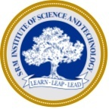
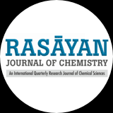
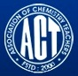

INTERNATIONAL CONFERENCE
ON
MODERN TRENDS IN CHEMICAL SCIENCES INCLUDING
GREEN CHEMISTRY
(MTCSGC - 2018)
27th to 29th December 2018

REPORT

The Department of Chemistry, SRM Institute of Science and Technology, Ramapuram Campus, Association of Chemistry Teachers (ACT), Mumbai and Rasayan Journal of Chemistry organized an International Conference on “Modern Trends in Chemical Sciences Including Green Chemistry-MTCSGC 2018” during 27th to 29th December 2018. Around 200 delegates including Professors, Scientists, Industrialists, Faculty Members, Research Scholars and Students from all over the world actively participated in this mega event.
Day One (27-12-2018)
Inaugural Function
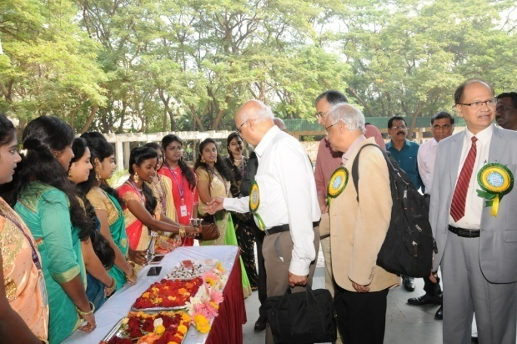 | 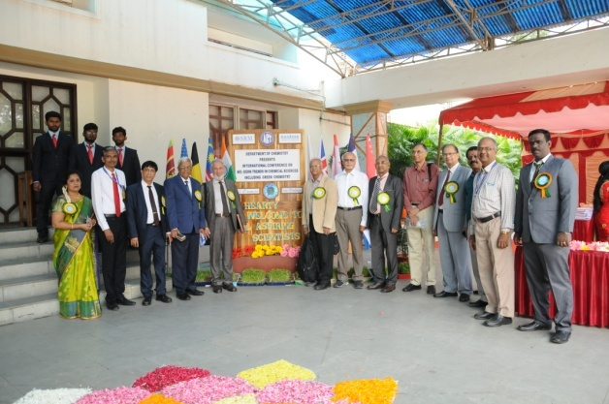
Arrival of the Guests for Inaugural Function
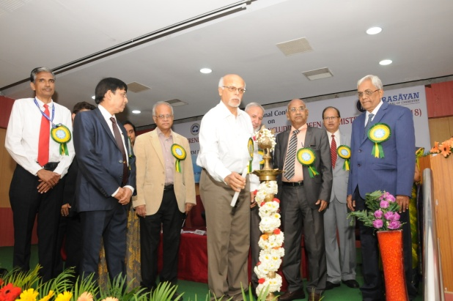 | 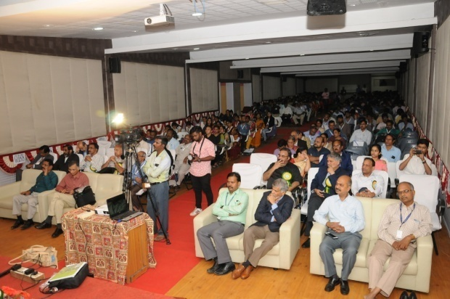
Lightning of the Kuthuvilakku by Chief Guest Prof. K.N. Ganesh-Director, IISER, Tirupati | Audience

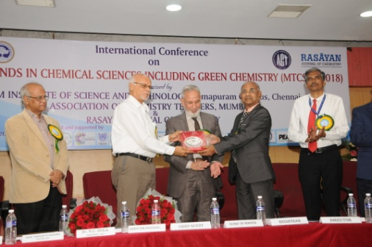 | 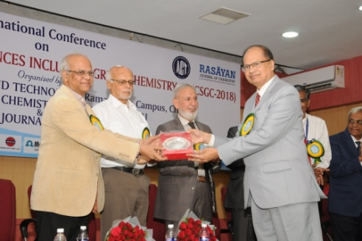
Honoring the Guests
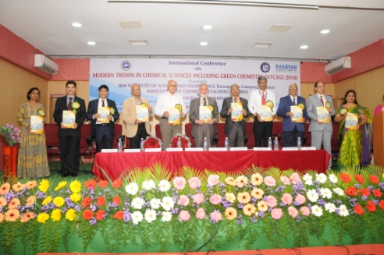 | 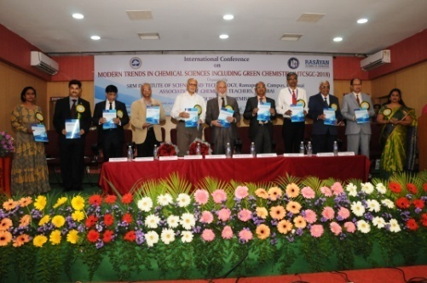
Releasing of Souvenir | New Journal Launching-GP Globalize Research Journal of Chemistry
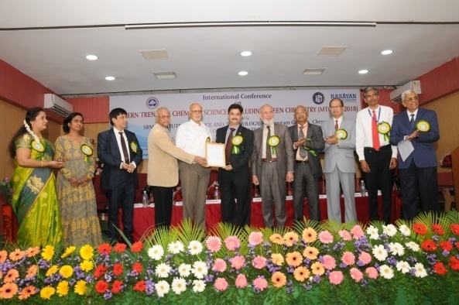
Life Time Achievement Award to Dr. S.K. Sharma, Editor, RJC

The Chief Guest of the Inaugural function, Prof. K.N Ganesh, Director, IISER-Tirupati inaugurated the programme and in his inaugural address, he mentioned “Experiments are important to endear students to Chemistry”. The Guest of honor Prof. N. Sathyamurthy, President of Chemical Research Society of India and Dr. D.C. Deka, President of ACT addressed the gathering.
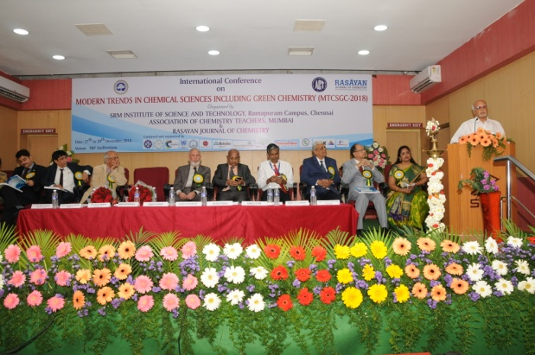
Inaugural Address by Chief Guest Prof. K.N Ganesh, Director, IISER-Tirupati
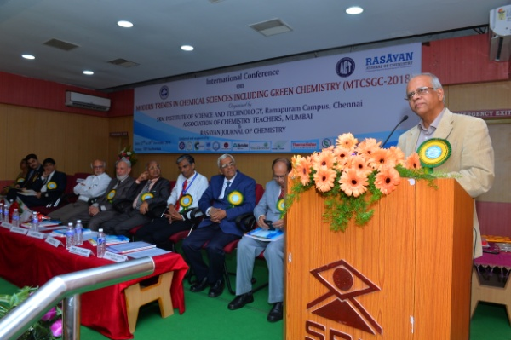 | 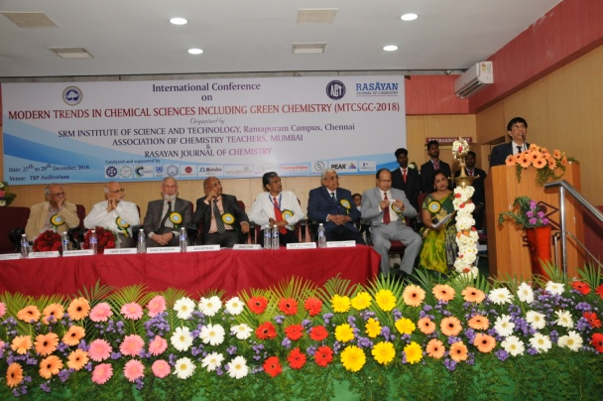
Guest of Honor, Prof. N. Sathyamurthy, President of CRSI  addressing the gathering | Dr. D.C. Deka, President, ACT  addressing the gathering

Earlier, Dr. V. Subbiah Bharathi, Director, SRMIST Ramapuram welcomed the gathering. Dr. N. Sethuraman, Registrar, SRMIST delivered a special address. Prof. D.V. Prabhu, Convener of MTCSGC-2018 and General Secretary of ACT detailed about the conference. Finally, Dr. Helen P. Kavitha, Convener of MTCSGC and Head, Department of Chemistry, SRMIST, Ramapuram gave vote of thanks.
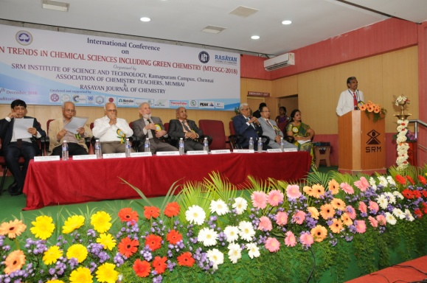 | 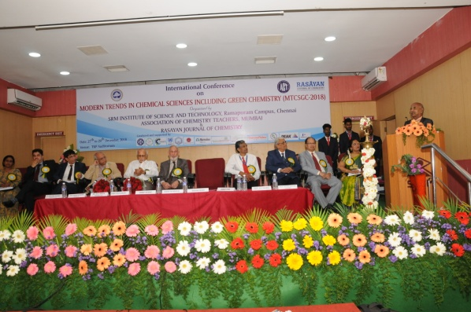
Welcome Address by Dr. V. Subbiah Bharathi  Director, SRMIST Ramapuram | Special Address by Dr. N. Sethuraman,  Registrar, SRMIST, KTR
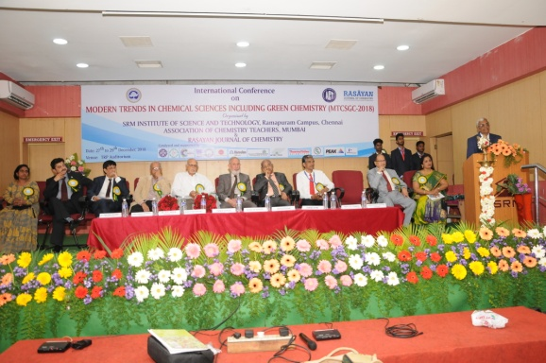 | 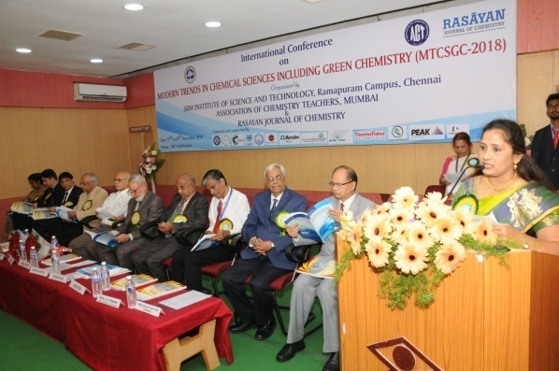
About the Conference by Prof. D.V. Prabhu,  Convener - MTCSGC 2018 | Vote of Thanks by Dr. Helen P. Kavitha,  Convener - MTCSGC 2018

Keynote Address
Prof. K.N. Ganesh, Director, IISER, Tirupati delivered Keynote Address and then Prof. N. Sathyamurthy, President, Chemical Research Society of India and Honorary Professor, JNCASR, Bengaluru delivered a Keynote lecture on “The Chemical Bond”.
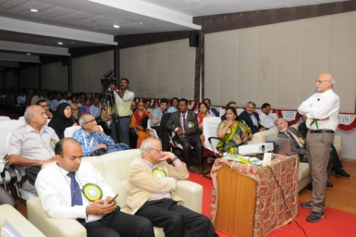 | 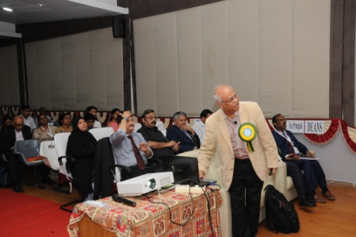
Keynote Address by Prof. K.N. Ganesh | Keynote Lecture by Prof. N. Sathyamurthy

Invited Lectures
There were many invited lectures by eminent scientists and professors on day one. Prof. Uday Maitra, IISc., Bengaluru delivered an invited talk on “Teaching Organic Chemistry in the 21st Century” and performed an interesting experiment. This was followed by Prof. S.B. Jonnalagada, University of KwaZulu-Natal, Durban, South Africa who talked about “ Green Principles and Catalysis for Synthesis and Water Treatment”. Third invited lecture was given by Prof. R. K. Sharma, Green Chemistry Network, University of Delhi regarding “New Developments in Green Chemistry” and then fourth lecture on “Friccohesity: Trend in Physicochemical Properties of Nanoemulsion” was given by Prof. Man Singh, School of Chemical Sciences, Central University of Gujarat, Gandhinagar.
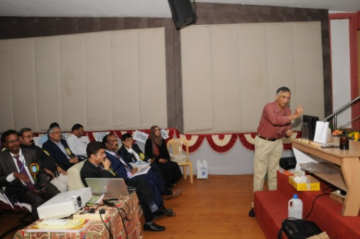 | 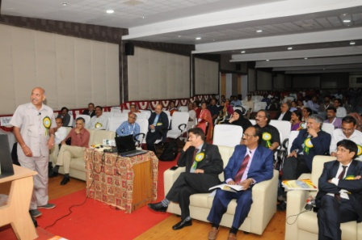
Prof. Uday Maitra (IL – 1) | Prof. S.B. Jonnalagada (IL – 2)
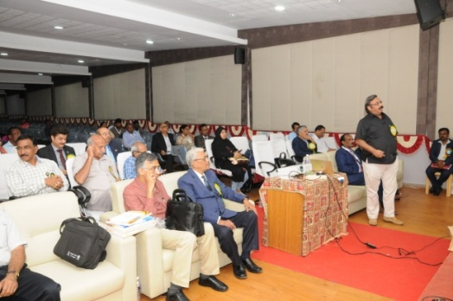 | 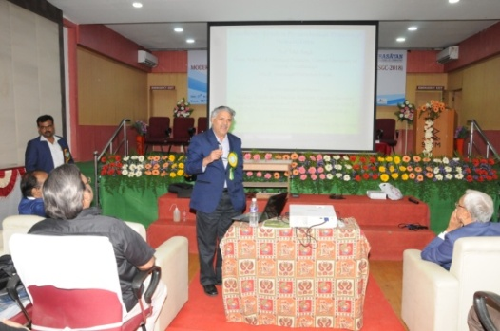
Prof. R. K. Sharma (IL – 3) | Prof. Man Singh (IL – 4)

Oral Presentations
25 research papers were presented by oral mode in parallel sessions on day one.
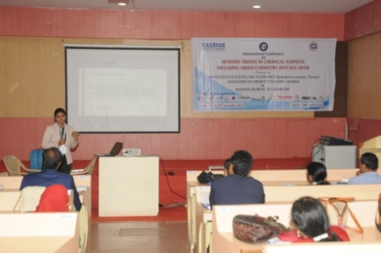 | 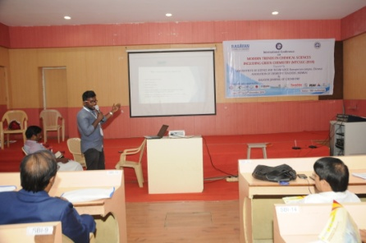
Oral Presentations by various participants

Day 2 (28-12-2018)
Invited Lectures
On day two, there were seven invited lectures on various topics.. “Synthesis of Carbon Nanotubes by Flame Fragments Deposition–Advantages and Disadvantages” by Prof. Falah H. Hussein, University of Babylon, Babylon, Iraq; “Application of GCMS Technique for the Analysis of Narcotic Substances” by Prof. G. Ramakrishnan, President, Chromatographic Society of India, Mumbai; “Synthesis, Characterization and Application of Anti-Corrosive Polyurethane Coating from Date Seed Oil” by Prof. Priy Brat Dwivedi, Caledonian College of Engineering, Muscat, Oman; “Towards a Vibrant Academia–Industry Synergy” by Dr. Prabodh Chobe, Former Regional Director, IGNOU, Mumbai; “International Science Olympiad programme-the harbinger of innovation in Science Education” by Prof. D.V.Prabhu, General Secretary of ACT, Mumbai;
“Catalysis-An Inevitable and Vital Component of Green Chemistry” by Prof. Radha V. Jayaram, Institute of Chemical Technology (ICT), Mumbai and “Ion Chromatography and its Applications” by Dr. Deepak Parab, Metrohm India Limited, Chennai.
Oral & Poster Presentations Cum Cultural Events Around 25 oral and 30 poster presentations were held as parallel sessions in day two evening. Cultural programme was also hosted and performed by SRM students.
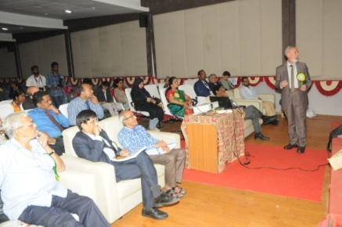 | 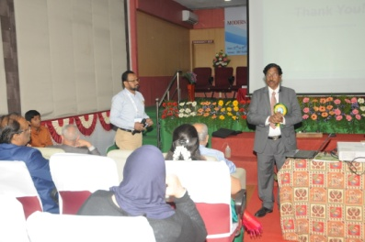 | 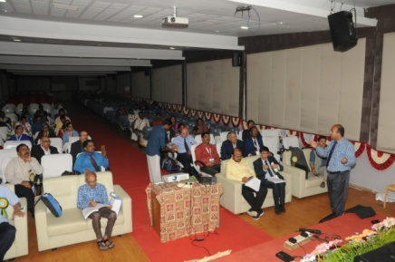
Prof. Falah H. Hussein (IL - 5) | Prof. G. Ramakrishnan (IL - 6) | Prof. Priy Brat Dwivedi (IL - 7)
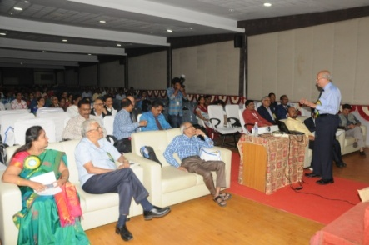 | 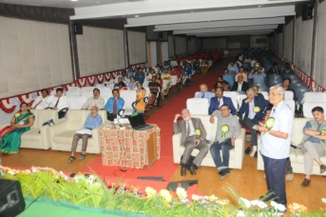 | 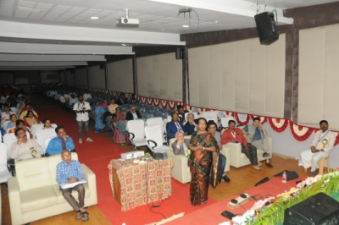
Dr. Prabodh Chobe (IL - 8) | Prof. D.V. Prabhu (IL - 9) | Prof. Radha V. Jayaram (IL - 10)
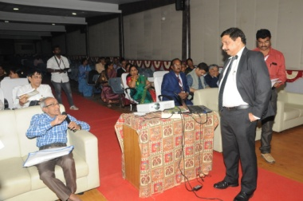 | 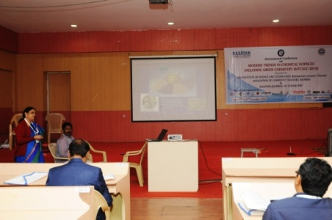 | 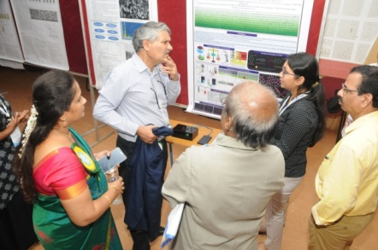
Dr. Deepak Parab (IL - 11) | Oral Presentation | Poster Presentation
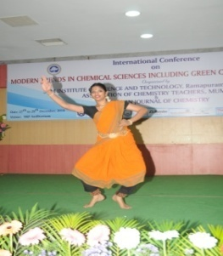
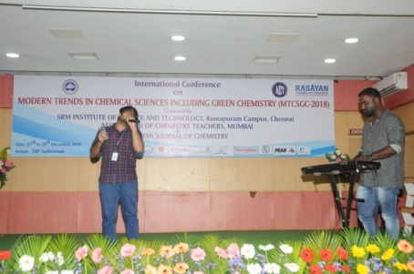

Cultural events performed by SRM students
Day 3 (29-12-2018)
Invited Lectures and Poster Presentation
The third day sessions started with poster presentations. 40 participants presented their research work in Poster mode.
There were about five invited talks on day three. Initially, Dr. B. Sreedhar, CSIR-Indian Institute of Chemical Technology, Hyderabad delivered a talk on “Nanoengineered Materials - Synthesis, Characterization and Catalytic Applications”.
Prof. Sheshanath Bhosale, University of Goa, Goa and School of Chemical Sciences, RMIT University, Melbourne, Australia delivered an invited talk on “Supramolecular Chemistry: Organic Functional Structures at the Nanoscale Level” followed by Prof. V. K. Garg, Centre for Environmental Science and Technology, Central University of Punjab, Bathinda, Panjab who delivered a talk on “Baseline Studies in the Vicinity of Proposed Nuclear Power Station”.
Prof. Sanjay K. Sharma, JECRC University, Jaipur delivered talk on “Greening the Chemistry Curriculum of K-12 Level: The Need of the Day”. Final lecture of the three day event was delivered on “Studies in Irradiated UHMWPE Oxidation” by Dr. Venkat Narayan, Anthara Technologies Consulting, Fort Wayne, IN, USA.
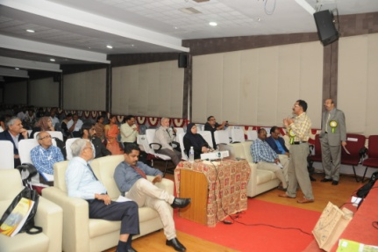 | 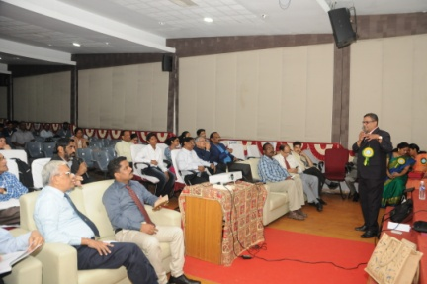
Dr. B. Sreedhar (IL - 12) | Prof. Sheshanath Bhosale (IL - 13)
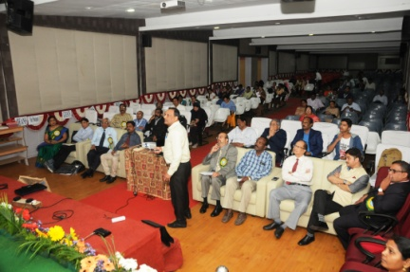 | 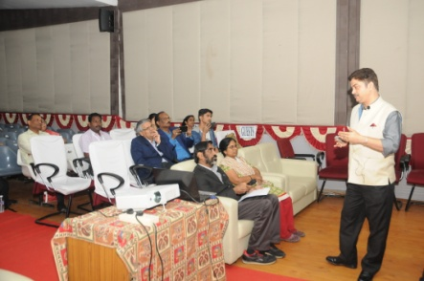
Prof. V. K. Garg (IL - 14) | Prof. Sanjay K. Sharma (IL - 15)
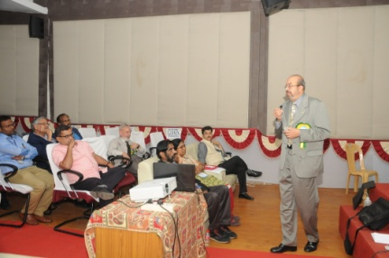 | 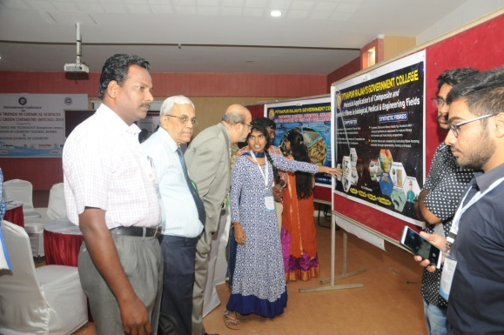
Dr. Venkat Narayan (IL - 16) | Poster Presentations

Valedictory Function
The Three Day International Conference ended with the happy note with the Valedictory Function. Dr. Mangala Sundar K, Professor & Head, Department of Chemistry, Indian Institute of Technology, Chennai graced the Valedictory function as the Chief Guest and distributed Prizes and Certificates to the Best oral and poster presenters. Certificates were distributed to all the delegates and participants of MTCSGC 2018.
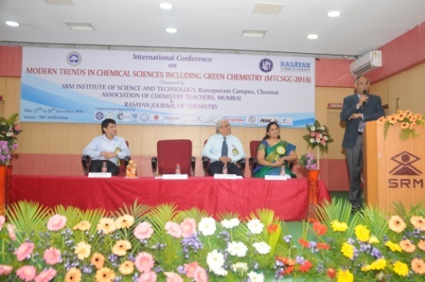 | 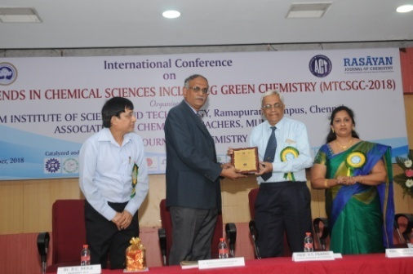
Dr. K. Mangala Sundar  Addressed the Gathering | Honoring of Chief Guest
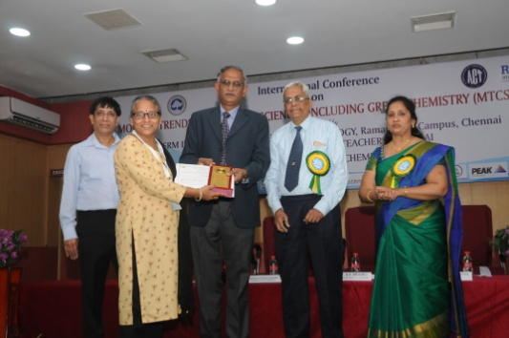 | 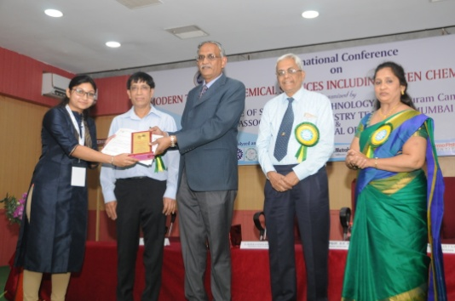
Best Oral Presentation Award | Best Poster Presentation Award

Group Photo
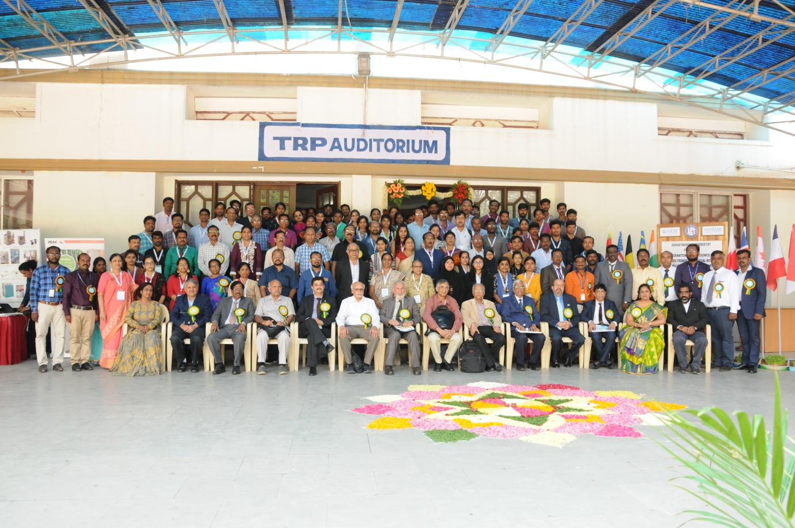
MTCSGC 2018 Delegates

